Name: Nachiket Jagdale
Class: A3-B1
Roll no.-02

PRACTICAL NO. 7
Aim: Implement Hamiltonian Cycle using Backtracking.
Problem Statement:
The Smart City Transportation Department is designing a night-patrol route for
security vehicles.
Each area of the city is represented as a vertex in a graph, and a road between two
areas is represented as an edge.
The goal is to find a route that starts from the main headquarters (Area A), visits
each area exactly once, and returns back to the headquarters — forming a
Hamiltonian Cycle.
If such a route is not possible, display a suitable message.
1) Adjacency Matrix
A B C D E
A 0 1 1 0 1
B 1 0 1 1 0
C 1 1 0 1 0
D 0 1 1 0 1
E 1 0 0 1 0

CODE:
#include <stdio.h>
#define MAX 10

int V;
int graph[MAX][MAX];
int path[MAX];

int isSafe(int v, int pos) {
if (graph[path[pos - 1]][v] == 0)
return 0;
for (int i = 0; i < pos; i++)
if (path[i] == v)
return 0;
return 1;
}

int hamCycleUtil(int pos) {
if (pos == V)
return graph[path[pos - 1]][path[0]] == 1;
for (int v = 1; v < V; v++) {
if (isSafe(v, pos)) {
path[pos] = v;
if (hamCycleUtil(pos + 1))
return 1;
path[pos] = -1;
}
}
return 0;
}

void hamCycle() {
for (int i = 0; i < V; i++)
path[i] = -1;
path[0] = 0;

if (!hamCycleUtil(1)) {
printf("No Hamiltonian Cycle exists.\n");
return;
}

printf("Hamiltonian Cycle found:\n");
for (int i = 0; i < V; i++)
printf("%c -> ", 'A' + path[i]);
printf("%c\n", 'A' + path[0]);
}

int main() {
printf("Enter number of areas (vertices): ");
scanf("%d", &V);

printf("Enter the adjacency matrix (%d x %d):\n", V, V);
for (int i = 0; i < V; i++)
for (int j = 0; j < V; j++)
scanf("%d", &graph[i][j]);

printf("\nSmart City Night Patrol Route:\n");
hamCycle();

return 0;
}

OUTPUT:
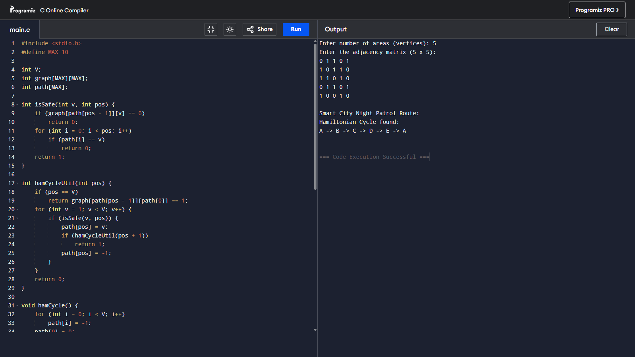

2) Adjacency Matrix
T M S H C
T 0 1 1 0 1
M 1 0 1 1 0
S 1 1 0 1 1
H 0 1 1 0 1
C 1 0 1 1 0
CODE:
#include <stdio.h>
#define MAX 10

int V;
int graph[MAX][MAX];
int path[MAX];
char names[] = {'T', 'M', 'S', 'H', 'C'};

int isSafe(int v, int pos) {
if (graph[path[pos - 1]][v] == 0)
return 0;
for (int i = 0; i < pos; i++)
if (path[i] == v)
return 0;
return 1;
}

int hamCycleUtil(int pos) {
if (pos == V)
return graph[path[pos - 1]][path[0]] == 1;
for (int v = 1; v < V; v++) {
if (isSafe(v, pos)) {
path[pos] = v;
if (hamCycleUtil(pos + 1))
return 1;
path[pos] = -1;
}
}
return 0;
}

void hamCycle() {
for (int i = 0; i < V; i++)
path[i] = -1;
path[0] = 0;

if (!hamCycleUtil(1)) {
printf("No Hamiltonian Cycle exists.\n");
return;
}

printf("Hamiltonian Cycle found:\n");
for (int i = 0; i < V; i++)
printf("%c -> ", names[path[i]]);
printf("%c\n", names[path[0]]);
}

int main() {
printf("Enter number of areas (vertices): ");
scanf("%d", &V);

printf("Enter the adjacency matrix (%d x %d):\n", V, V);
for (int i = 0; i < V; i++)
for (int j = 0; j < V; j++)
scanf("%d", &graph[i][j]);

printf("\nSmart City Night Patrol Route (T M S H C):\n");
hamCycle();

return 0;
}
OUTPUT:
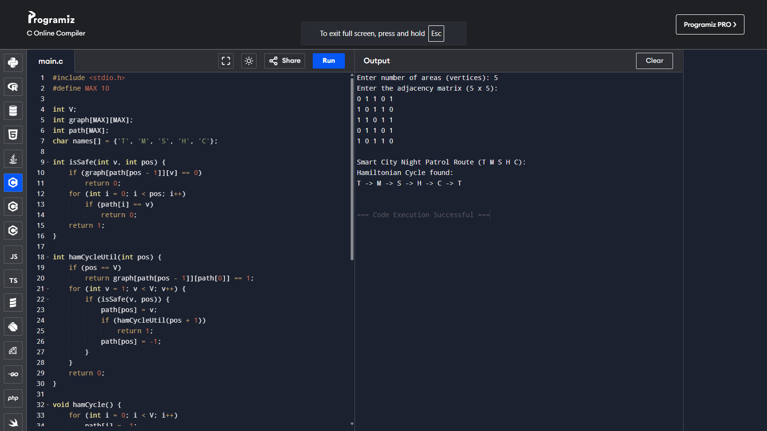

Competitive Coding Link:
https://www.geeksforgeeks.org/problems/hamiltonian-path2522/1

Code:
import java.util.*;
class Solution {
boolean check(int n, int m, ArrayList<ArrayList<Integer>> edges) {
boolean[][] graph = new boolean[n + 1][n + 1];
for (ArrayList<Integer> e : edges) {
int u = e.get(0), v = e.get(1);
graph[u][v] = true;
graph[v][u] = true;
}
boolean[] visited = new boolean[n + 1];
for (int i = 1; i <= n; i++)
if (dfs(i, graph, visited, 1, n)) return true;
return false;
}
boolean dfs(int node, boolean[][] graph, boolean[] visited, int count, int n) {
visited[node] = true;
if (count == n) return true;
for (int v = 1; v <= n; v++) {
if (graph[node][v] && !visited[v])
if (dfs(v, graph, visited, count + 1, n)) return true;
}
visited[node] = false;
return false;
}
}

OUTPUT:


